Software Design

Software overview:

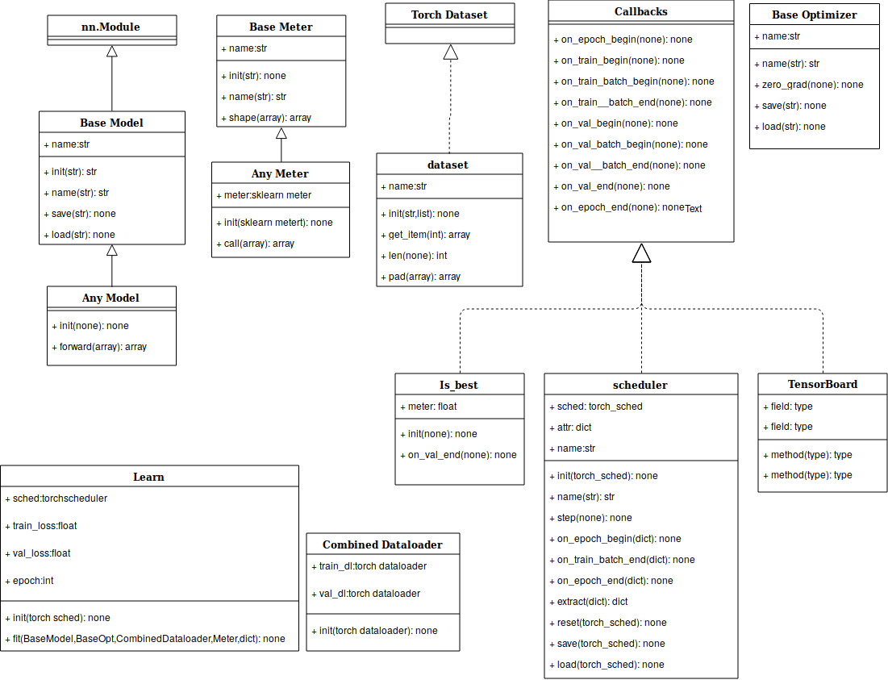

The previous figure shows the different classes that are implemented in the software.

Our software consists of classes and methods we will pass by each class give an overview on it, explain only the unfamiliar components, Then we pass by other methods that don’t belong to a class.
Base Model: located basemodel.py
Represents the base class for all customized modules
It provides the model with basic features as saving and loading its state dict
Note:Inputs provided from the dataset are in the type and shape needed for the loss function,So Models must:
1- Ensure consistency of Input to its components regarding type and dimensions
2- Return the output in the shape and type needed for the loss function.
Consists of:
- __init__
- __name__ :Used in saving model by its name
- save
- load

Optimizer : located optmizer.py
Represent wrapper for torch optimizer class
Provides same interface of an optimizer and ad some functionalities to it.
Consists of:
- __init__
- __name__
- zero_grad
- step
- save
- load

Scheduler : is located in scheduler.py
Represent a wrapper to torch schedulers, it implements the callback class.
Consists of:
- __init__
- __name__: Used for tag generation
- step
- get_lr
- on_epoch_begin: Set the scheduler as the attribute of fit this helps in passing scheduler to the learner class.
- on_train_batch_end
- on_epoch_end
- extract:Extracts numeric parameters of scheduler to reset it when needed
- reset : Gurantee that at the end of the epoch the lr will be reset
This is important when using SGDR
- save
- load

dataset: located in data_handler.py
Implements Pytorch Dataset
Inputs:
base_dir: path to the dataset
index(list): Indices of file in case not all data will be used
dim(list,tuple,number): target dimension needed for the loss function
mode(str): center or right padding
word_type(type): to give the examples specific type needed in the loss function as float or int
Output:
Padded - reshaped single example or mini-batch
Consists of:
- __init__
- __getitem__
- __len__
- pad: Responsible for padding the input to fit required dimensions

CombineDataloader: located in data_handler.py
Takes train dataloader and validation data loader and combine the in one object
Consists of:
- __init__

Callbacks: located in callbacks.py
Base class class for all components that will use the callbacks concept
It contains different functions that represent different stages through the training and validation phase
Note: **Kwargs attribute must be added to any implemented method from the callbacks
Consists of:
- on_epoch_begin
- on_train_begin
- on_train_batch_begin
- on_train_batch_end
- on_val_begin
- on_val_batch_begin
- on_val_batch_end
- on_val_end
- on_epoch_end

BaseMeter: located in meter.py
Base Class for metrics.
Provides the meters with name method to help in presenting result.
Consists of:
- __init__
- shape
  - Method check any inconsistency in type or shape of predicted and true values.Inconsistency occurs due to different representation needed among loss functions and meters
  - Inputs:
    - pred(tensor): represent the predictions of the model
    - true(tensor): represent the true values of the model

  - Output:
    - pred: 1D numpy array
    - true: 1D numpy array

accuracy: located in meter.py
Implementation for accuracy using sklearn.
Consists of:
- __init__
- __call__

f1 score: located in meter.py
Implementation for accuracy using sklearn.
Consists of:
- __init__
- __call__

Class Is_best: located in cbs.py
Search for the best model each epoch and save it if needed, implements callback class.
Consists of:
- __init__
- on_val_end

Class learner: located in fit.py
Class where training takes place, it has some arguments that help callbacks to reach the parameters of the model since sending and returning parameters through callbacks is very complicated.
Consists of:
- __init__
- fit

Methods

Split:Located in data_handler.py
Function: splits dataset to training and validation
Input:
base_dir(str): path to the dataset
prc(float) : ratio between validation set size and dataset size
dataset_pct(float) :percentage of dataset to be used
Output:
train dataset
val dataset
Example:
split('dataset/binary dataset/',dataset_pct=0.12,dim = (1,112,112), mode= 'center' ,word_type = torch.LongTensor)

tqdm , clear_tqdm : Two methods located in fit.py
Responsible for the gui used to represent the progress of training

calc_metrics: located in meter.py
Method used to loop over multiple meters provided to fit function

gen_tag: located in utils.py
Generate a unique tag or name based on the model components
Could include time if needed to guarantee uniqueness of models

create_dir: located in utils.py
Creates directory in the given path and notify if directory already id writes in it

save_all: located in utils.py
Save all model details (model,optimizer,scheduler)

load_all: located in utils.py
Load all model details in place (model,optimizer,scheduler)

Classes and methods by files
basemodel.py
- Class BaseModel
callbacks.py
- Class Callbacks
cbs.py
- Is_best
data_handler.py
- Class dataset
- Class combineDataLoader
- split method
fit.py
- Class learn
meter.py
- ClassBaseMeter
- Class accuracy
- Class f1
- calc_metrics method
optimizer.py
- Class BaseOptmizer
scheduler.py
- Class scheduler
utils.py
- gen_tag method
- create_dir method
- save_all method
- load_all method

None: Tensor board class in represented in the image but not implemented actually but it will use the same concept of callbacks and this is the intended UML representation to the class.

